

User Manual of BPM

Date: 04/04/2022

Author: Abhishek Rai

Phone- 9554774033

Executive Summary

Managing business processes is a huge challenge in most organizations. Many business owners assume that it is a huge expense or that it is only worth it for massive processes. However, BPM is important no matter what size your business is. Here’s a definitive guide to managing your business processes with the help of automation.

**Business process management (BPM) is how a company creates, edits, and analyzes the predictable processes that make up the core of its business.**

Introduction

Objective

The objective of this manual is to present our new features in the latest version of the PO application. We will be discussing the new features i.e. BPM and its functionality. Following the point, we will be focussing-

* Business Objects Configuration
* Form Builder
* Email Notification
* Workflows Designer
* Workflow Association

# Business Process Management

In PO8 application provides customization for the user. Users don’t have to follow defined process or form. Users can make their own process and build forms according to their needs and requirements. Forms can be built for:

* Tickets
* Action
* Issue
* Change
* Document
* Risk

Business Objects Configuration

* Creating Library

Here we will create the library for ht form component. Here we will create a form component that is used in making a form. It is the initial step for form creation. Creating a library is available for all users in organizations.

Creating Library

* Process Configuration
* Tabs
* Sub Tabs
* Sections
* Data Tables
* Dropdown
* List Boxes
* Fields
* User Control

The following steps are used to define the libraries in Business Objects Configuration.

1. Click on Company settings.
2. Click ***Business Objects Configurations*** under company settings.

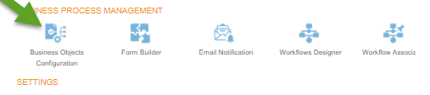

1. After clicking on Business Objects Configuration, the user will be directed to the Objects Configuration page where he can define a library that will be used for Form Building.

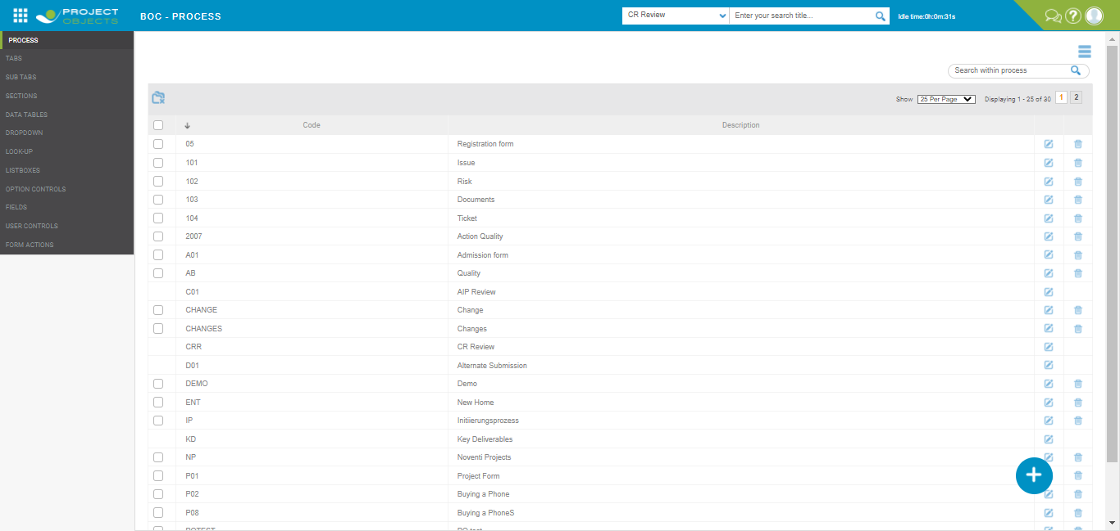

1. Click on the process tab and create a new process. Fill in the required information and click save. The form can be built with the unique combination of process and form type i.e. A combination of one process and one form type is allowed to build only one form.

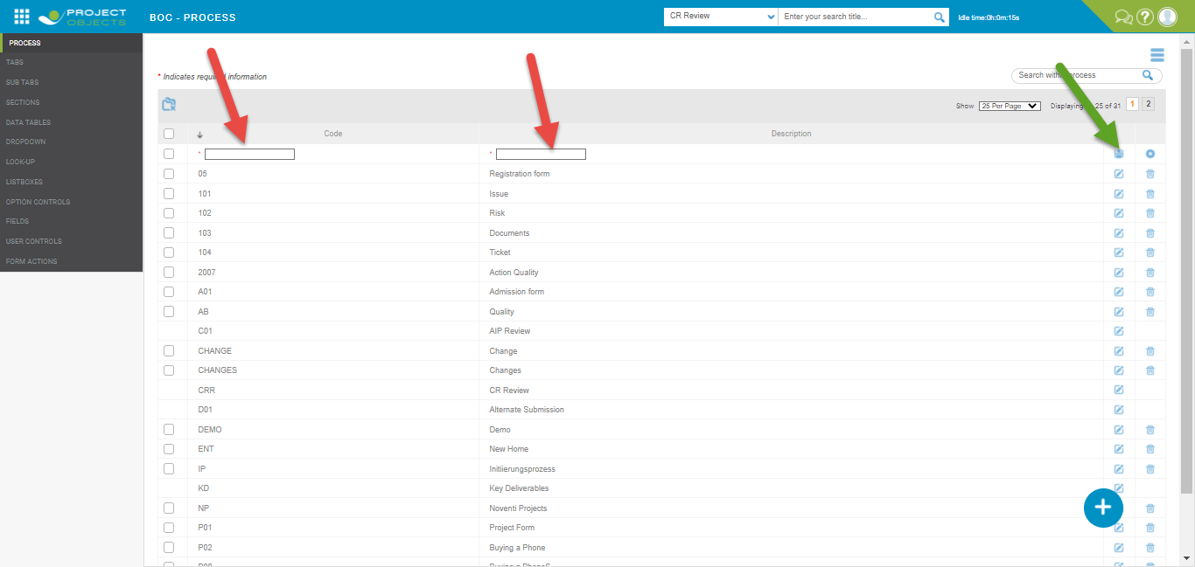

5- Click ***Tabs,*** then click ***Create New*** and fill in the required information and click to save.

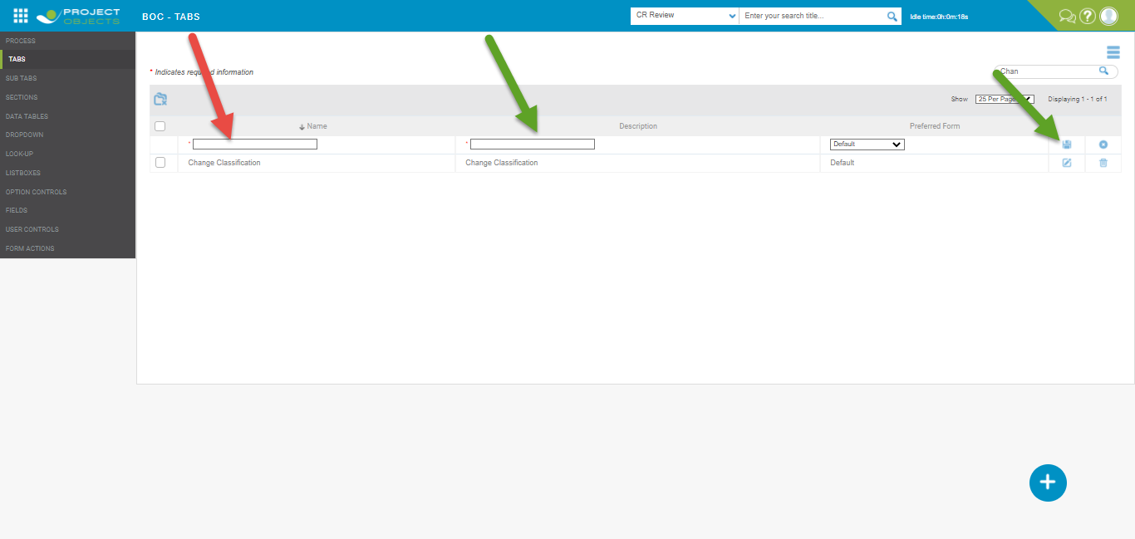

1. Click Sub Tabs, then click Create new and fill the required information and click to save.

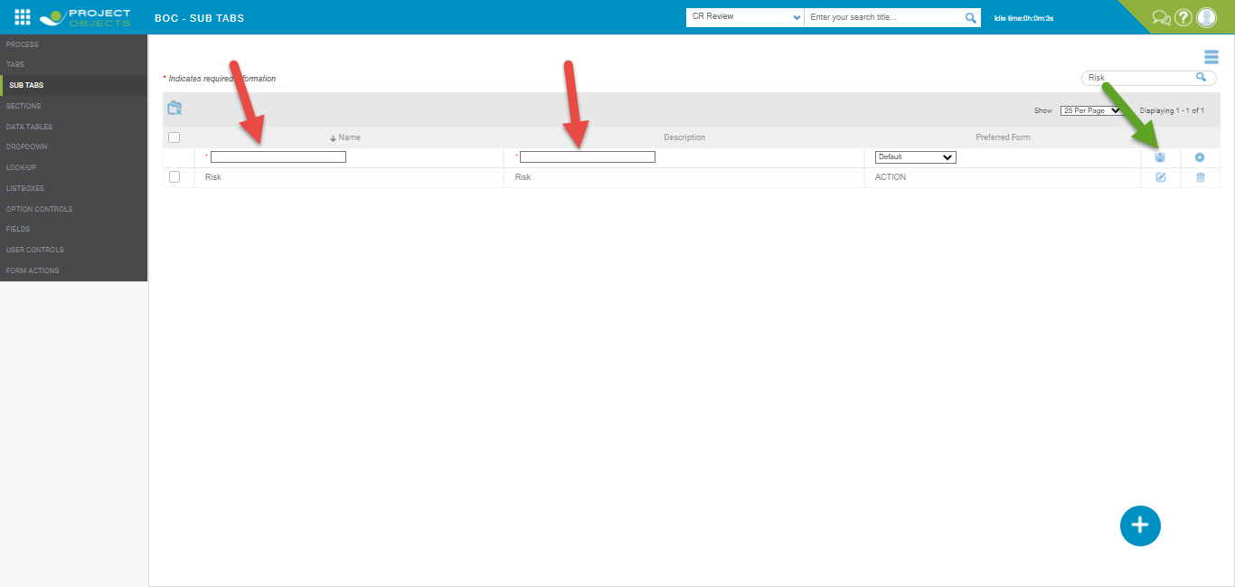

1. Click ***Sections*** and then click Create New, fill the required information and then click save.

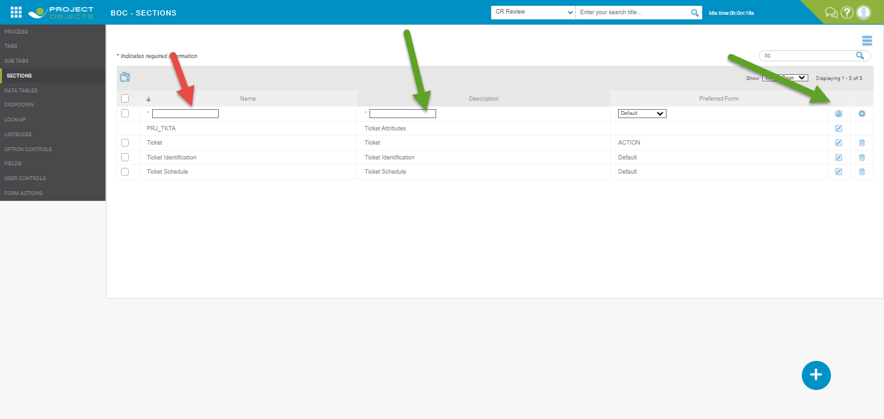

1. Click ***Data Tables*** tab and Create Table name. Click  to define table name.

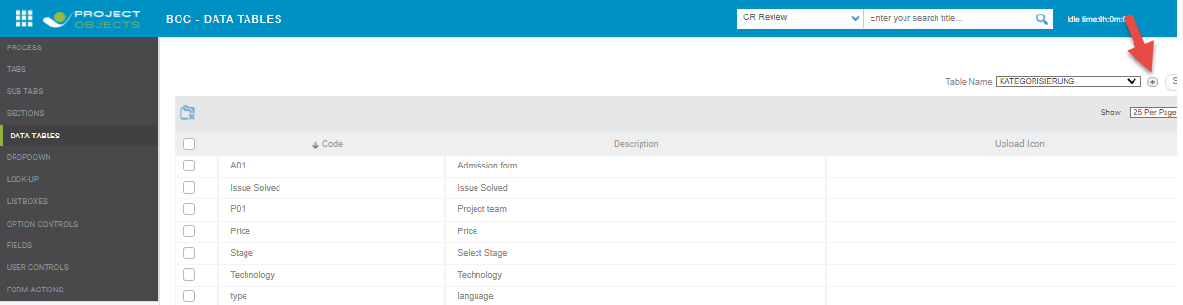

1. Now click ***Create New*** to create a table name. Fill in the required information and click save. Here, the table name will be defined that will be used in form to show the data of table.

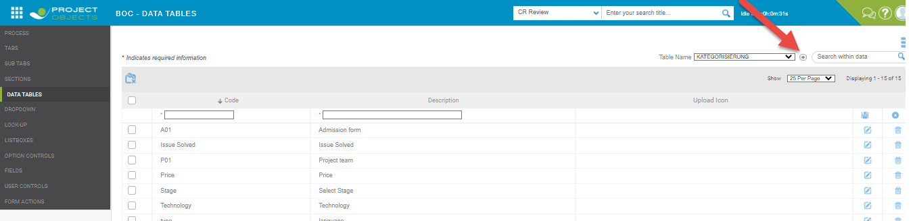

1. Now we will make ***a Dropdown*** for the Form. This dropdown can be used in building the form. Click the Dropdown tab and click ***Create New***. Under Table Name, some system-defined tables will be available by default and the tables which the user had created. Even if a user has not created any table then also you will get some system-defined table here for selection. Fill the required information and click Save.

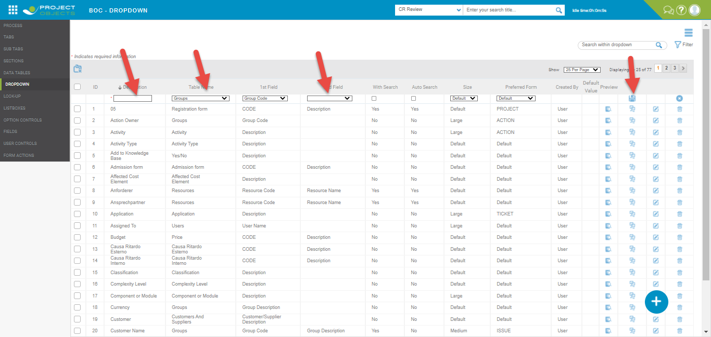

1. we will create ***Text/Note/Date/Number*** ***Fields*** that will be used in Form building. Click the Fields tab and then click ***Create New***. Fill in the required information and click save.

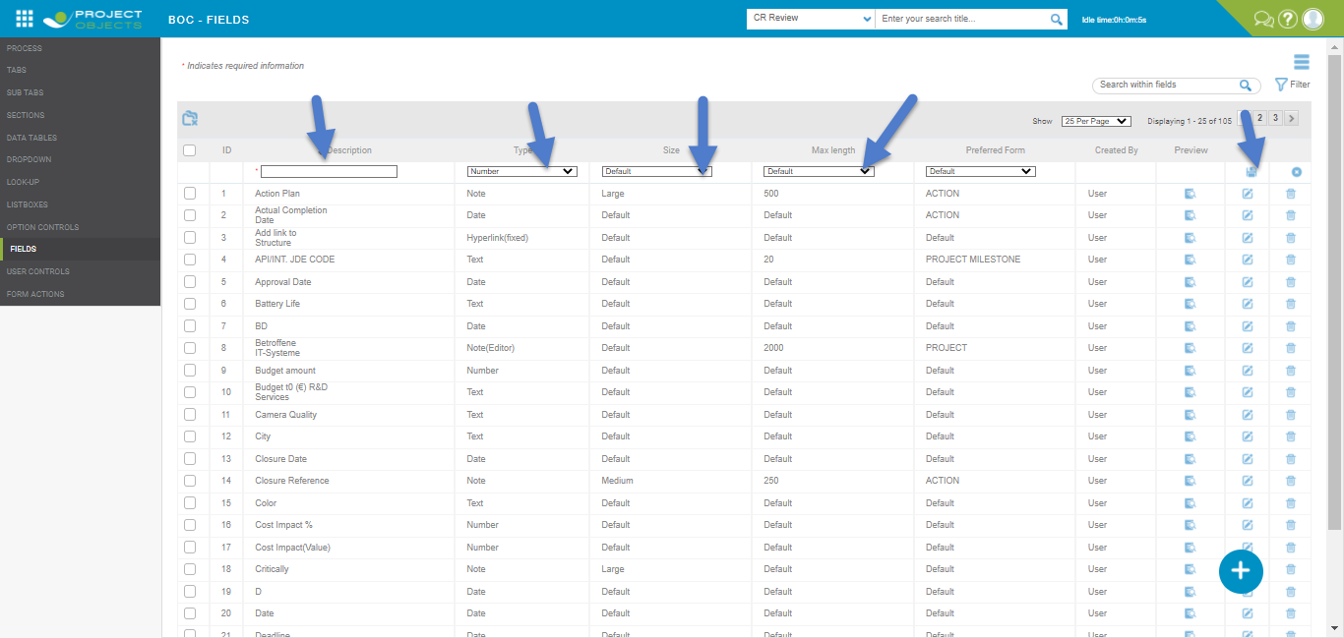

11-There is ***User control*** tab that contains the system defined controls, controls here cannot be deleted but can be edited

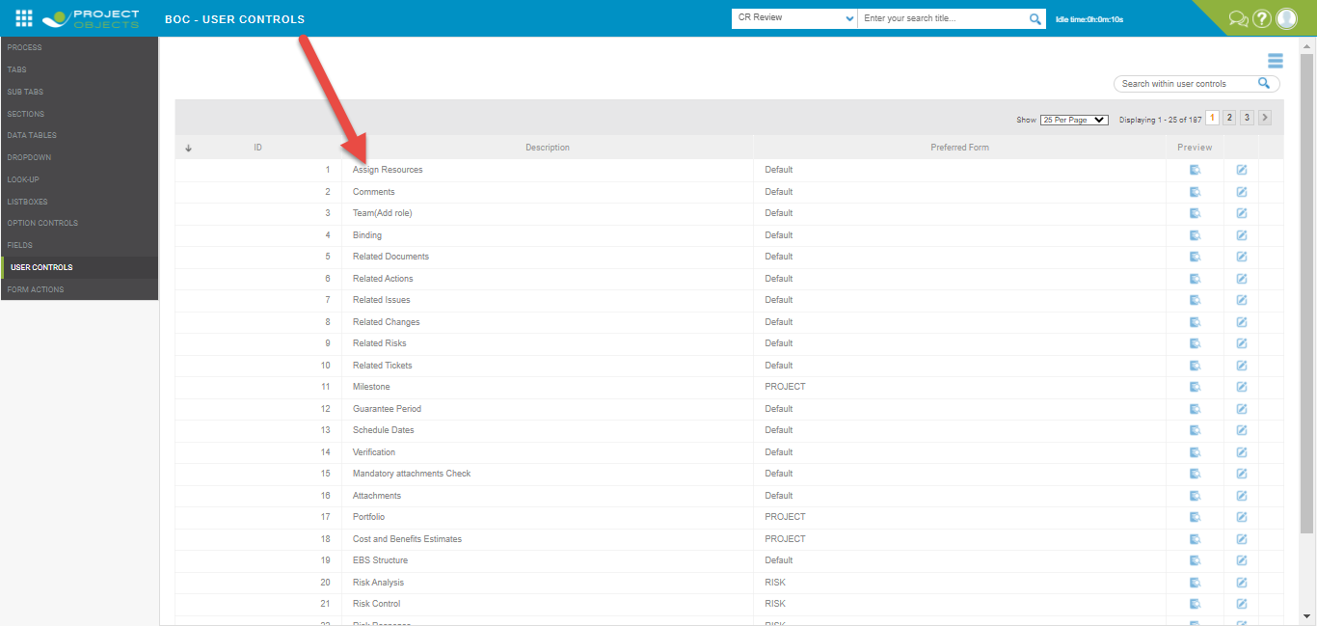

Lookup-Lookup is used to take the data from outside for the dropdown table using the connection string. Write the connection string to fetch the data from outside.

1- Click ***Look-Up*** then click **Create New**. After filling required information click Save. Here under Connection String, the user needs to write the connection string from where data will be fetched. Under Query, the user needs to write query for data.

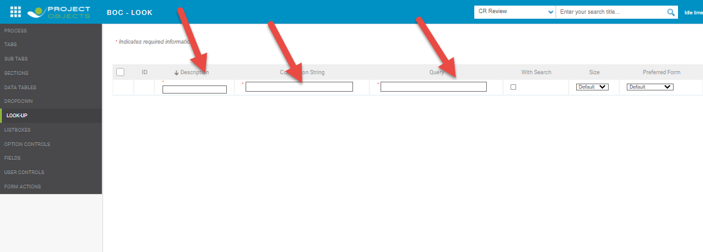

Option Control-

***Option Control*** is used to give options from which users can make a selection. The check box and the Radio button are used for options selection~~s~~.

1. Click ***Option Control*** then click ***Create New***. After filling required information click to save.

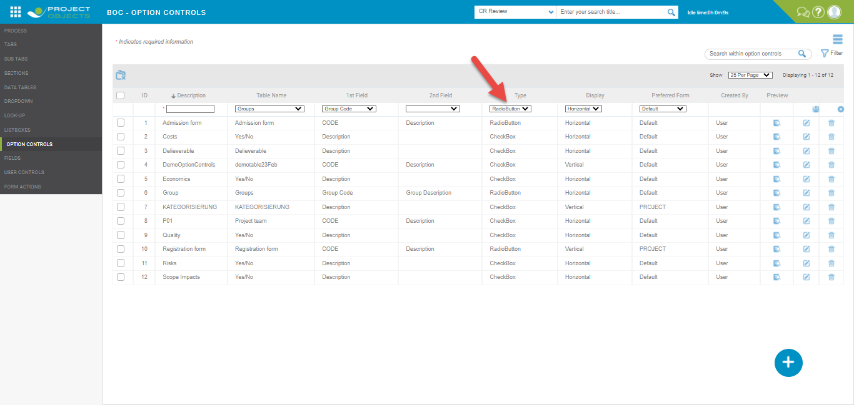

Form Builder

1-Click ***Form Builder*** under company settings.

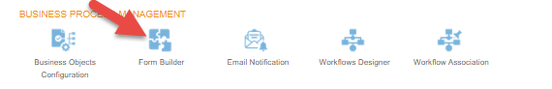

2-We will be directed to the Form Register page. To create a Form, click  ***Add new button***.

3-After this will be directed to the Form Builder page; here you can build a Form according to your requirement~~s~~. First, you have to select ***Form*** and ***Process,*** which has to be a unique combination.   
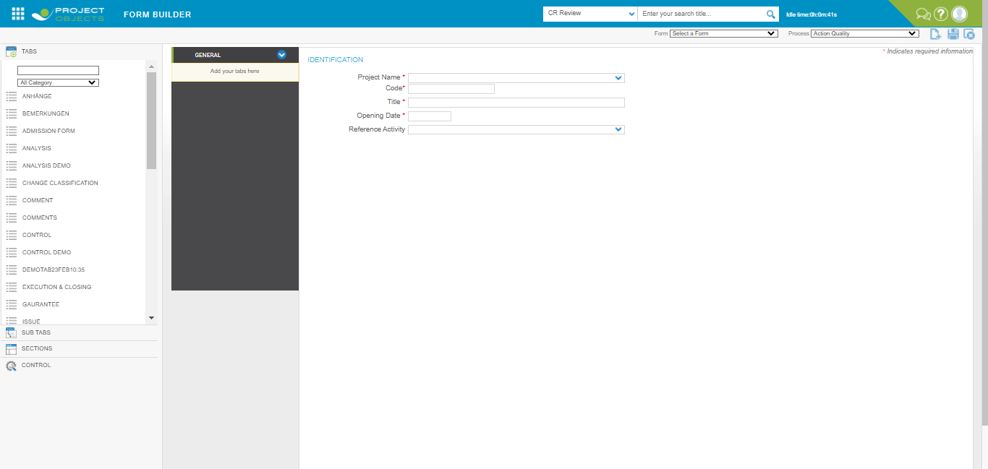

4-Select ***Tab*** which you want to place in your Form and drag it to the tab section. Under this ***Sub Tab*** is also available that can be used like this.

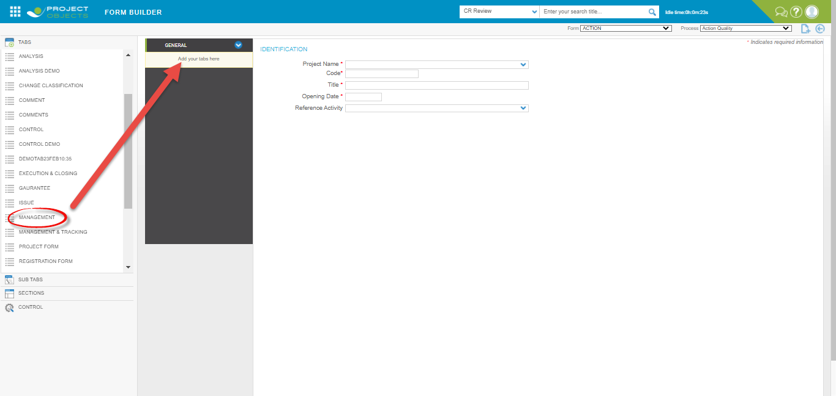

5-Select Tab in the Form under which you want to place a ***Section***. Now select the Sections tab and select a particular section and drag it to the Form.

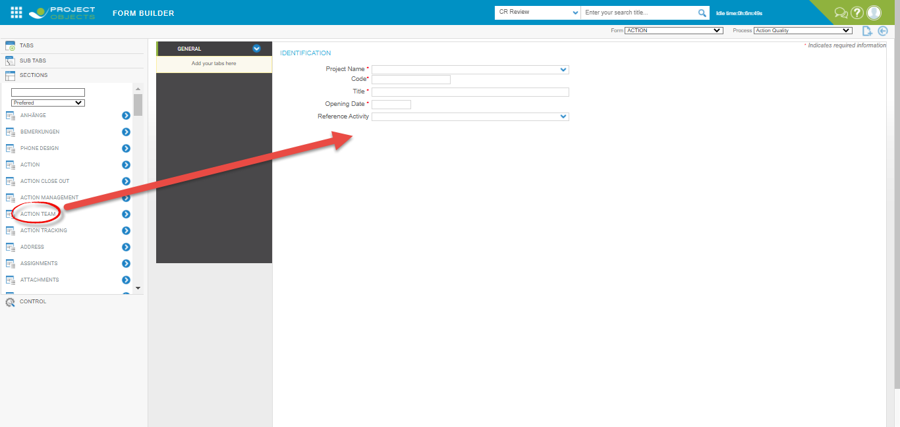

6- **Dropdown –** This shows the dropdown list of the data which you have selected under this while creating it.

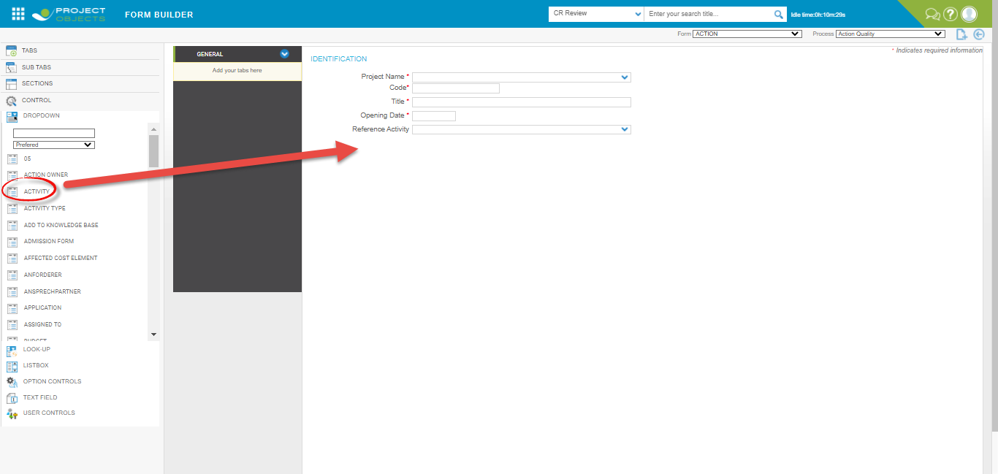

7-**Option Control –** This is used for selection in check boxes and radio button.

**8-Text Fields –** This is used for entering text/number/date**.**

**9-User Control –** Here system defined Control is available that can be used in Form.

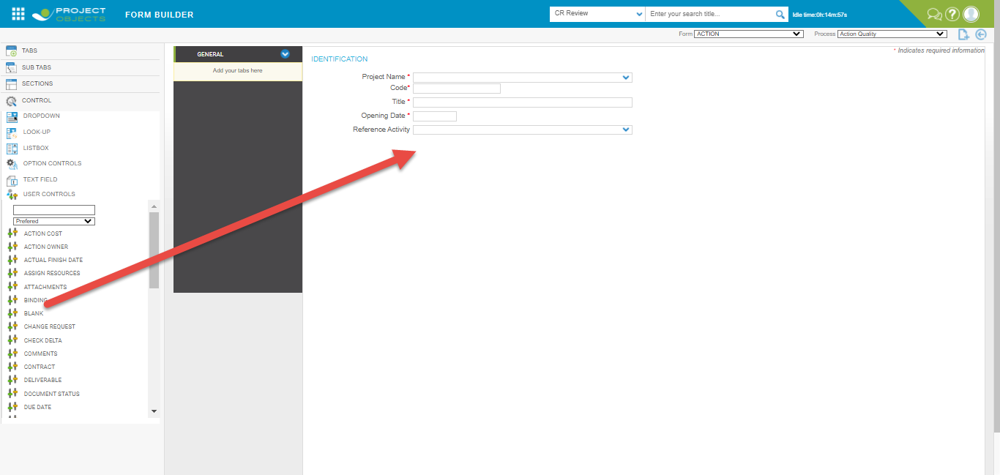

**Note-I create an Issue, Action, change, document, risk, tickets form using above process.**

**Create Issue Form**

1-Before creating form creation process and library are used in crating a form.

2-First select form and process.

3-Click on Tabs and add tabs in the form.

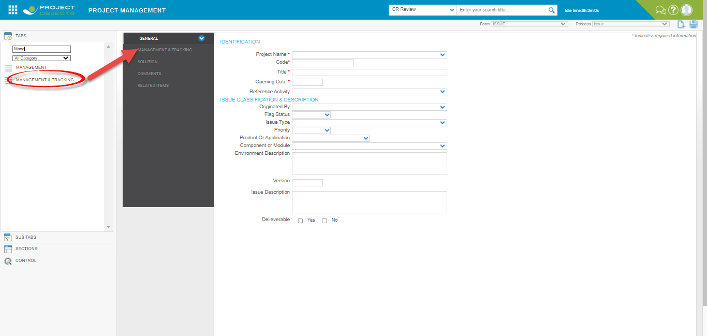

1. After adding tabs add sections in the added tabs.

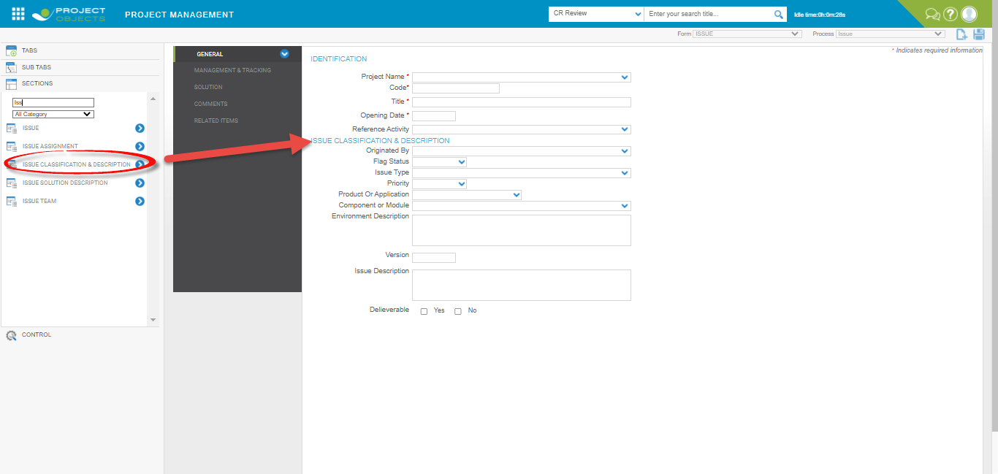

1. Add dropdown in the form which are create in the library.

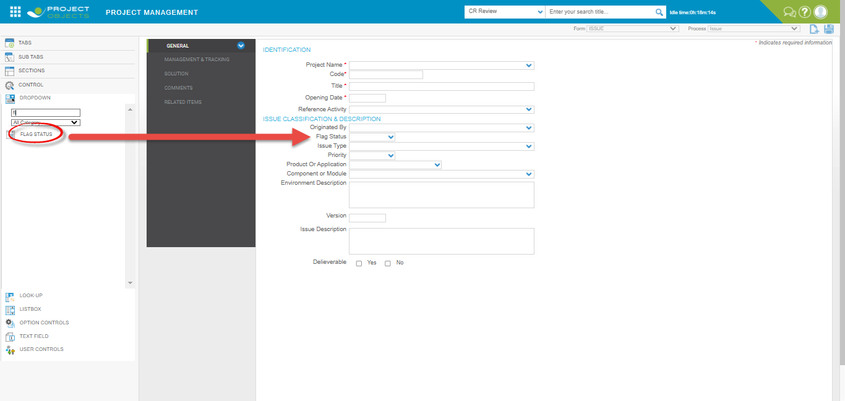

6-checkbox and radio button are added by using option control library

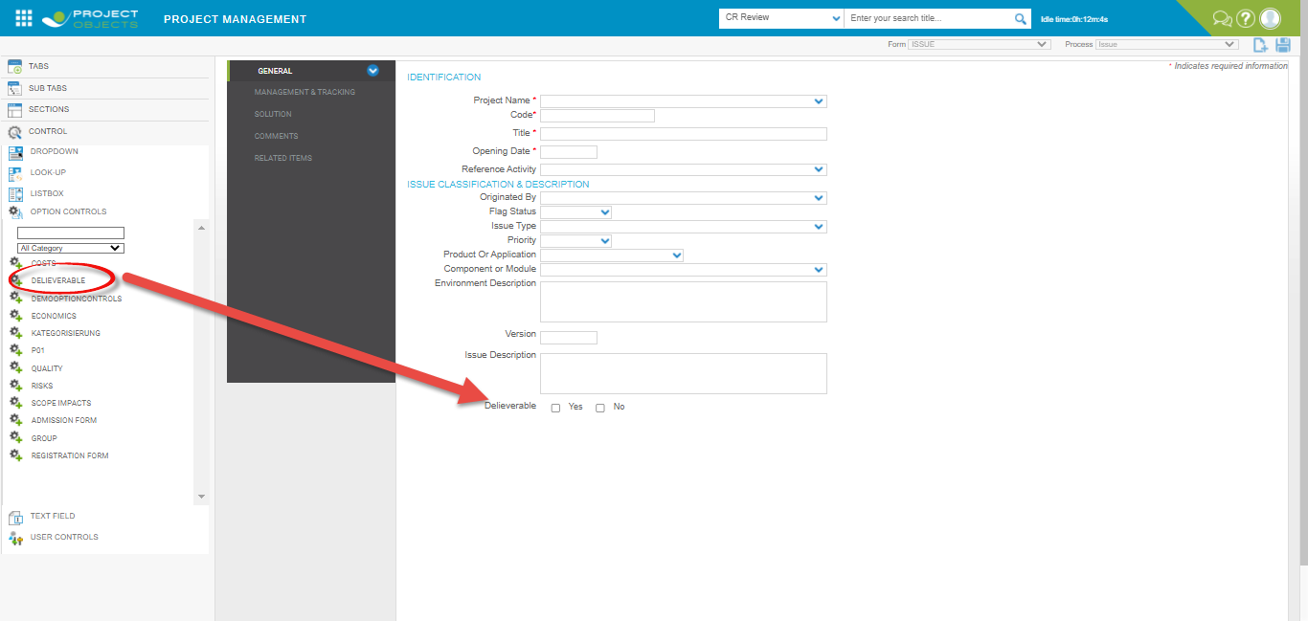

1. Text field are added in the form using text field library.

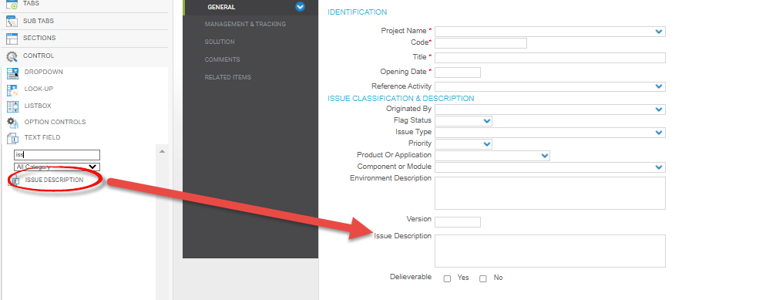

1. Options control are user-defined control that are using creating a form.

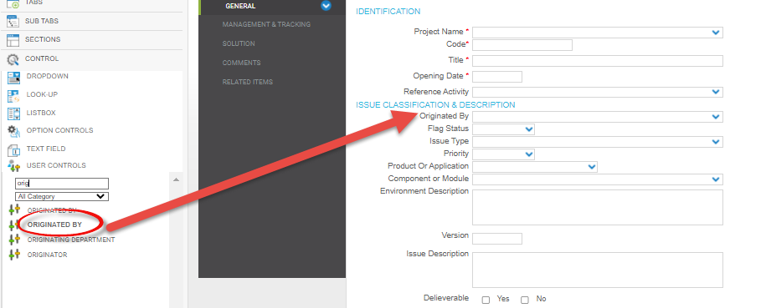

1. Sub tabs are used to add a tab in a root tab.

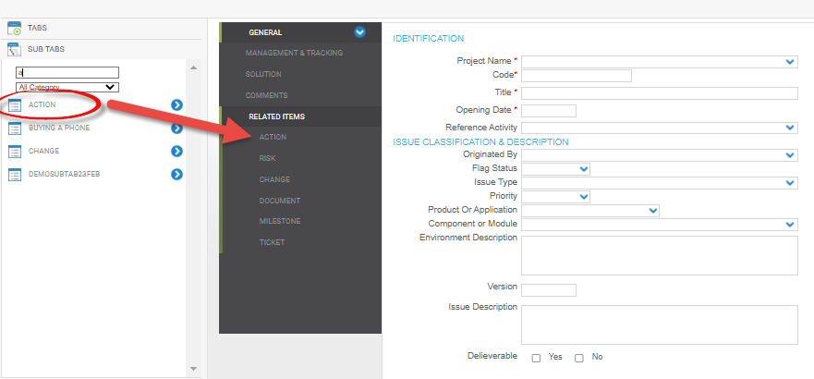

Note-All other form are created above process.

Workflow Designer

1-Click Workflow designer in company settings.

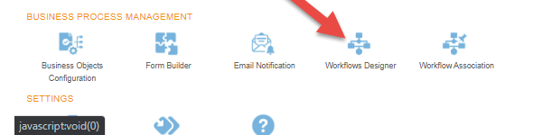

2-Select workflow type and process for which we want to create a workflow. I select Issue workflow type and process in workflow management page.

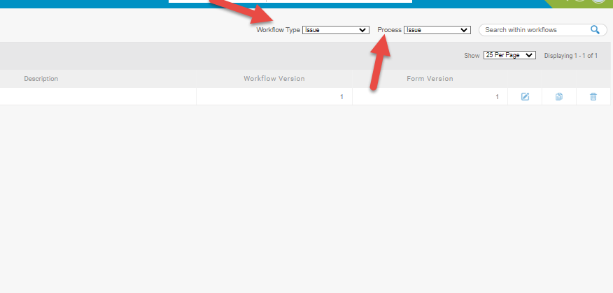

3-Click Create new button

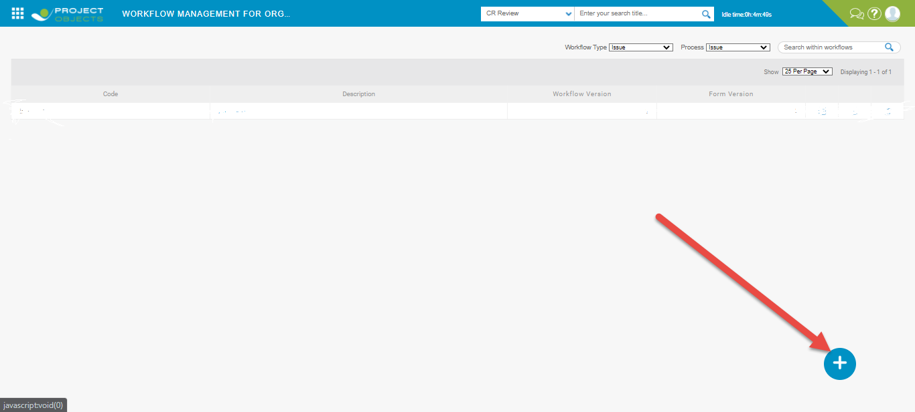

4- After click add new button new page is open. In General section fill the required information in general section like process manager select who will be having full control on the workflow.

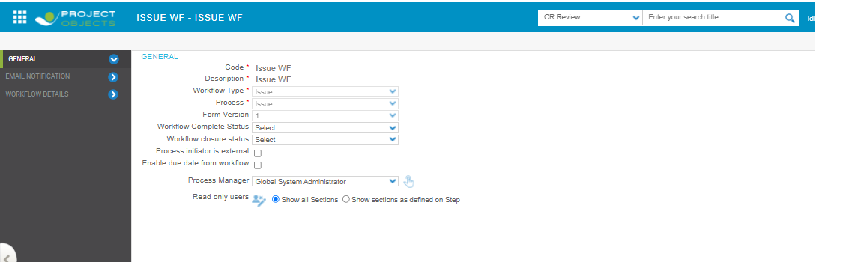

5- After fill required information click apply button.

6- click on workflow details tab four properties are available in this section.

* Form Section
* Associated Projects
* Advance Options
* Follow

7- Fill the information for three-step user and click save one by one.

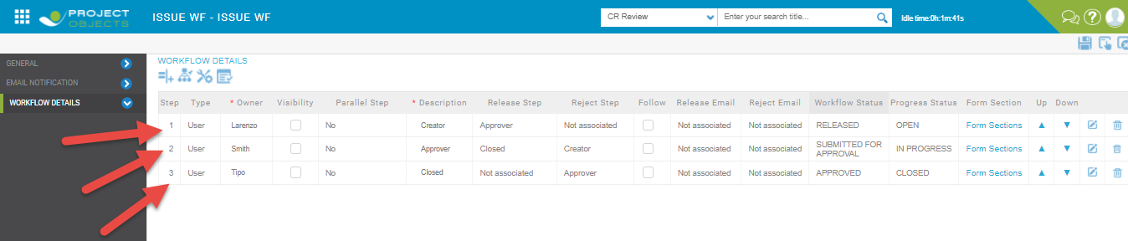

**Form Sections**

Form section is provide the visibility of section to the step owner. Step owner select the section from the list of section.

1-click on Form Section popup open then select the section which we want in checkbox then click apply and save.

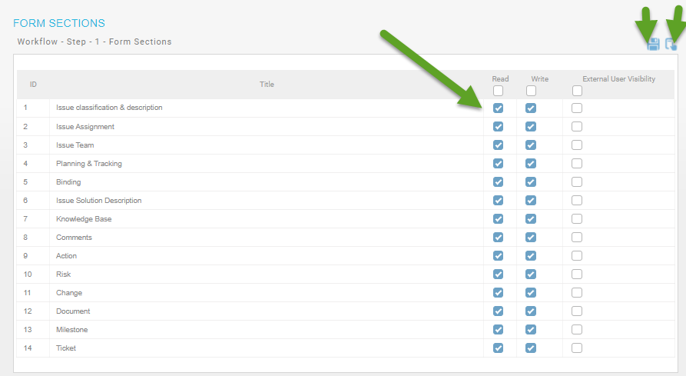

**Associated Projects**

We can select the projects which this workflow will be associated with it

1. Click Associated projects

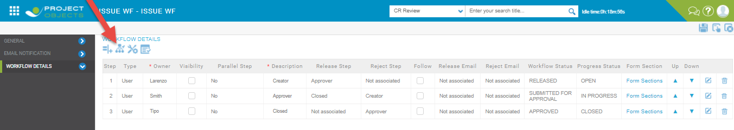

2-You will be directed to Project association page select the Associate Projects and click save and close.

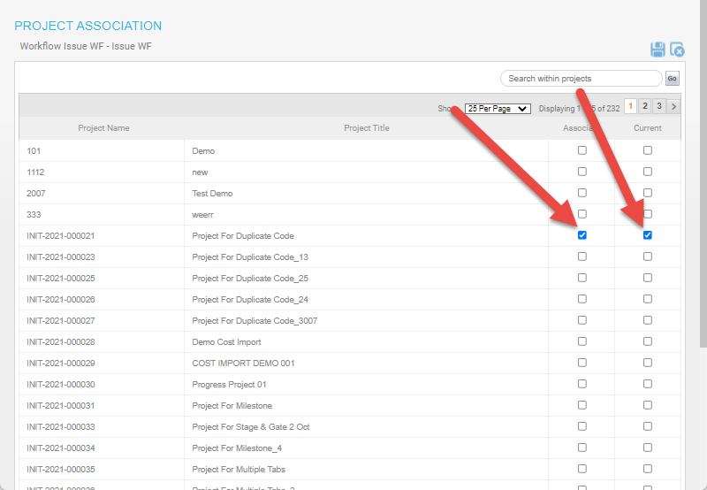

**Advance Options**

1. Click Advance options

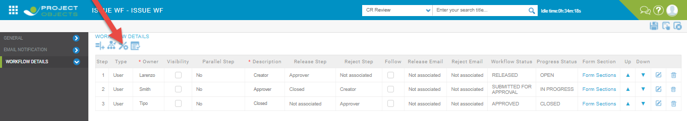

1. After clicking on Advance options popup open here different options are available for the step owner.

**Enable close**-enable close allow the step owner to close the process.

**Execution-**

a-Apply enable close to the second step owner.

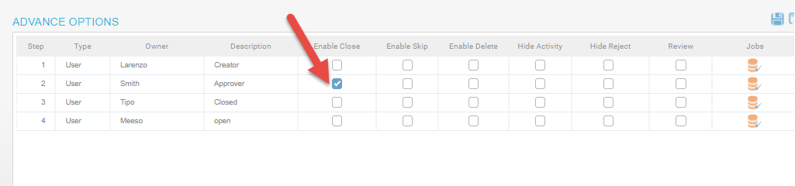

b- create a form and release it from first step owner then login from second step owner enable close option is available for this user.

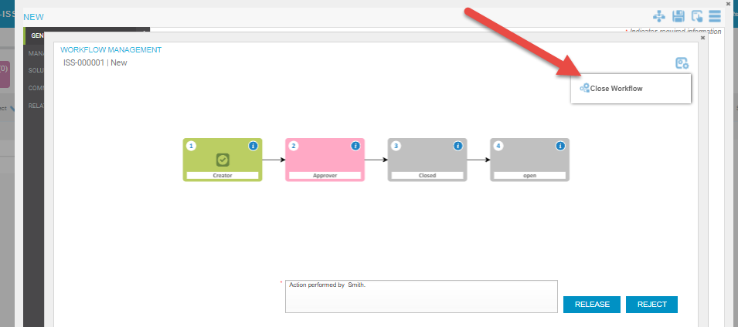

c-After applying close workflow progress status look like this-

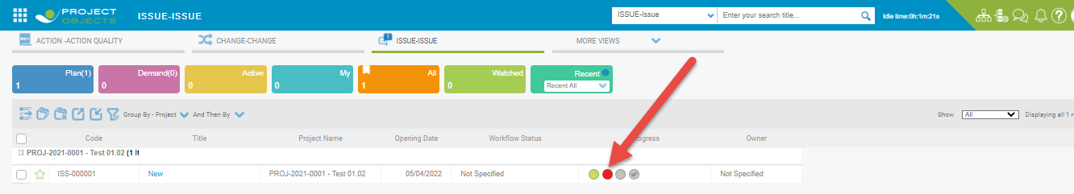

**Enable Skip**

Enable the skip option to allow the step owner to skip the step.

**Execution**

a-Enable skip apply to the second step owner and click apply and save.

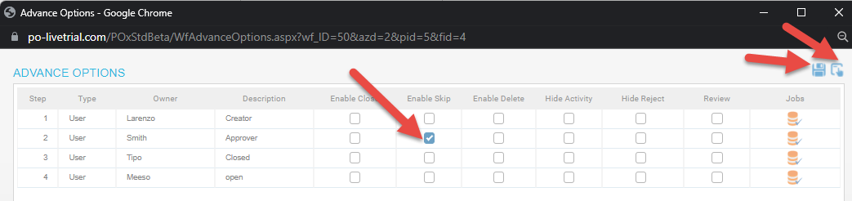

b-First release from first step owner then login from second step owner enable skip control are available for this step owner. Here we can skip the particular step and control go to the other step owner which we want.

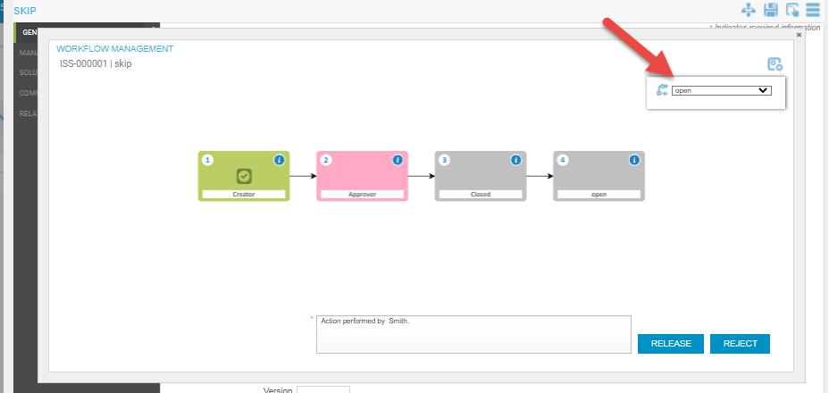

c- After release from the second step owner then progress status should like this-

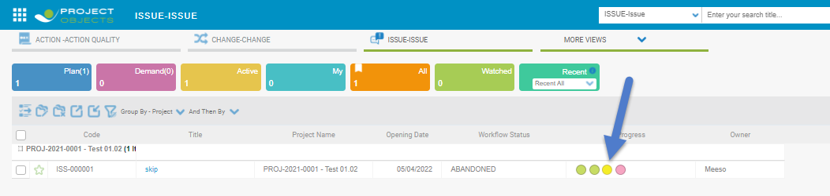

**Enable Delete**

Enable delete option will be permit the step owner to delete the particular process.

**Execution**

a-Enable delete will be applied on the second step owner. This step owner will be access to delete the process.

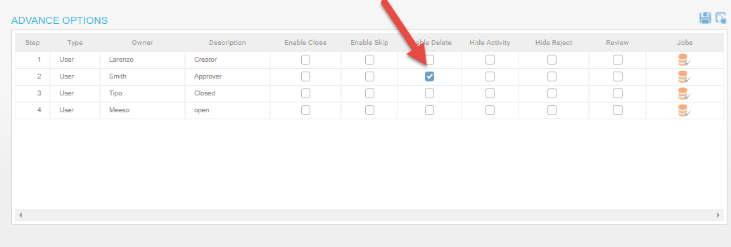

b-After release from the first step owner enable delete option will be available for this step owner. This step owner can delete the process.

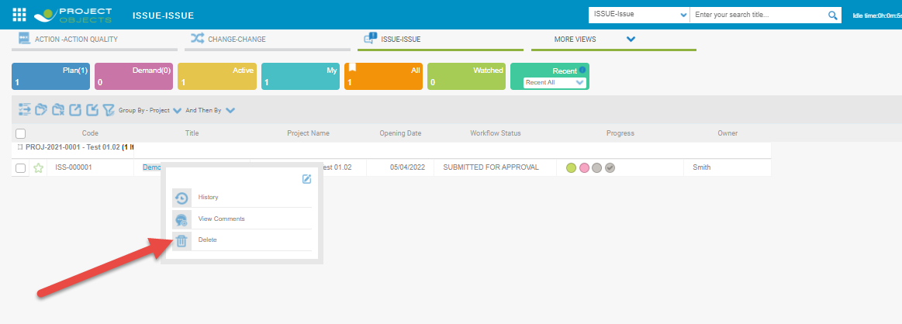

**Hide Activity**

The step owner will not be permit to see the activity of process.

**Execution**

1. Apply hide activity on second step owner .

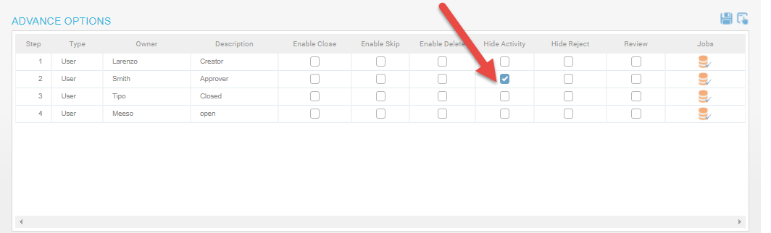

b-Release from first step owner then go to the second step owner and click on the Title to check the hide activity.

**Follow**

Follow is use to make the step mandatory to be followed during workflow.

**Execution**

a-First click edit on grid where we want to apply click in follow checkbox.

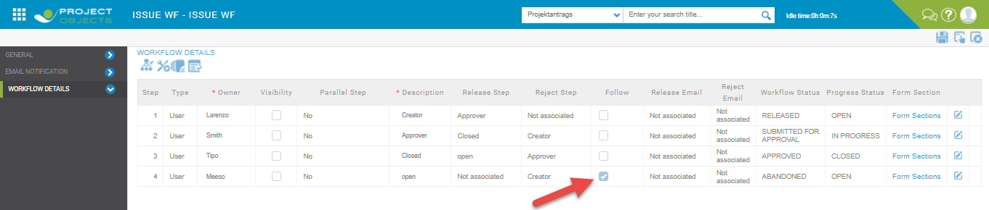

b-when we release to from the second to fourth step owner and reject from the fourth step owner process will be start from the first step owner.

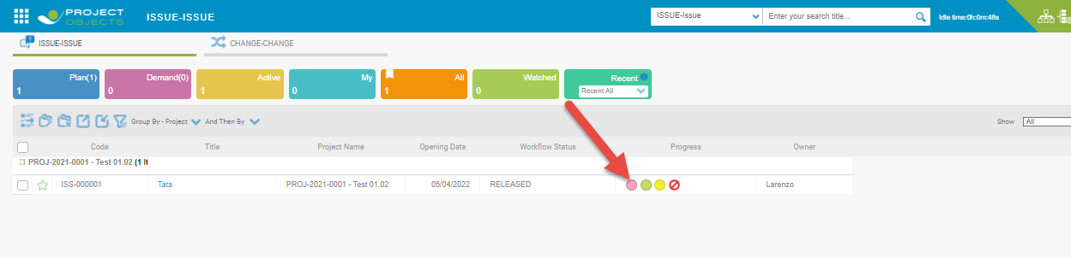

c-when I apply without using follow and reject from the fourth step owner then process will be go where will come.

**Hide Reject**

Hide reject can disappear the reject button where we release the process.

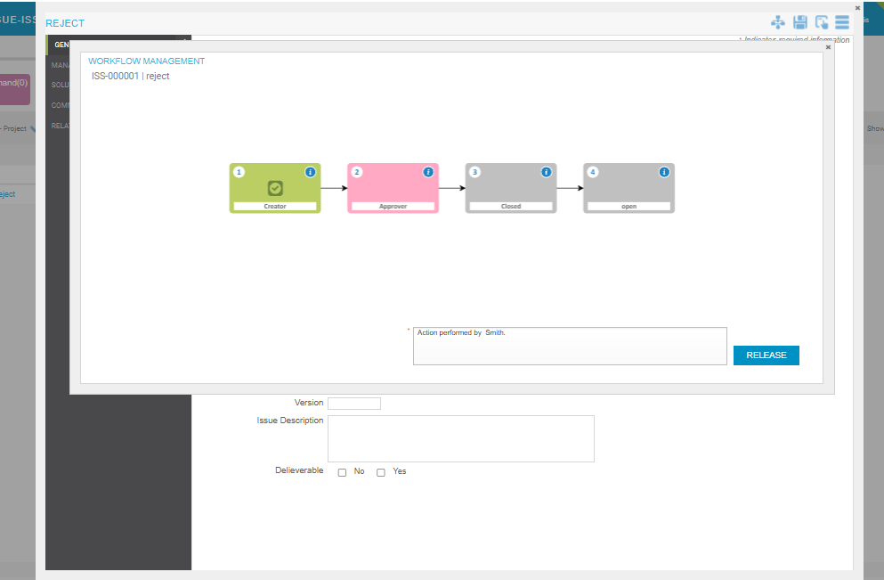

Workflow Association

1. Click Workflow Association in company settings.

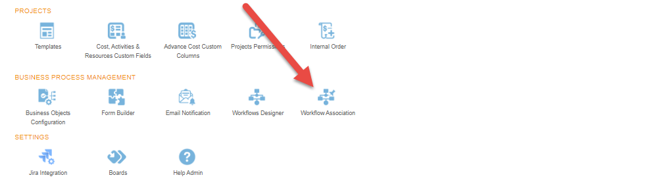

1. Select workflow type and process . Click Not specified to project which we want to define workflow.

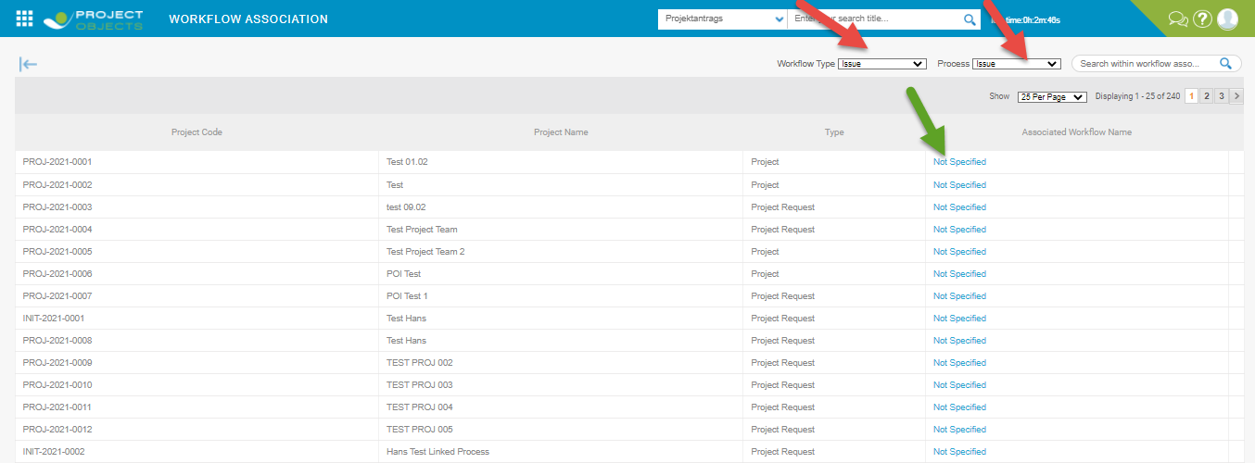

1. You will be directed to Workflow Setting page; here you can associate workflow for project and click to save.

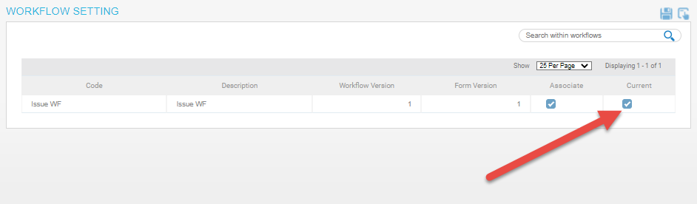

Email Notification

1. Click Email Notification in company settings.

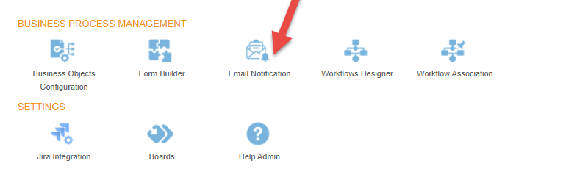

1. After click we go to the email configuration page and click create new button. I create a email service when release a process and fill required information.

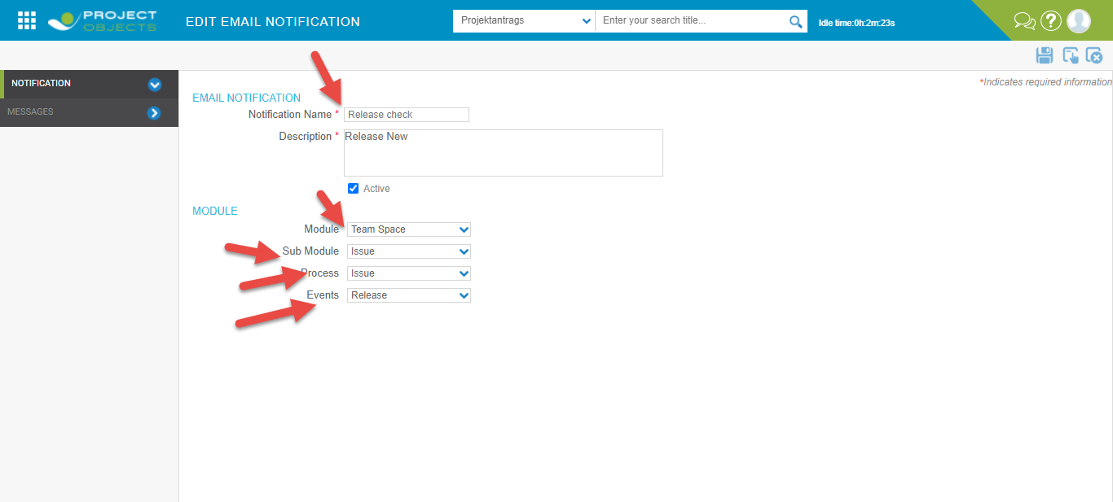

1. Message tab contain the information which we sent in the mail.

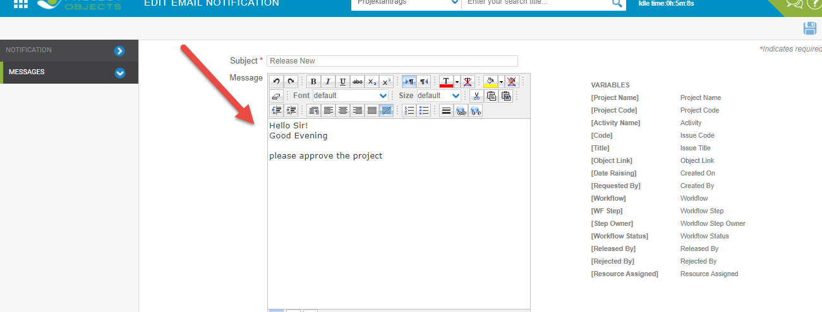

**Associate and Current**

Associate and workflow are used together in workflow design and workflow association, when we only apply association then we can not create a object on a particular project.

**Copy**

We create a exact copy of the created workflow.

1. Click on copy icon in form builder.

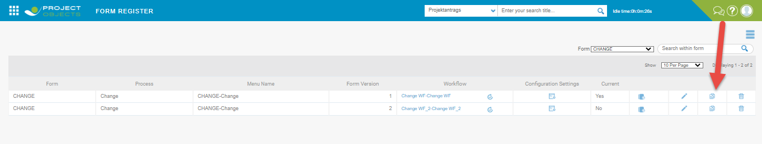

1. After click on icon open a popup to select the process where the form copy.

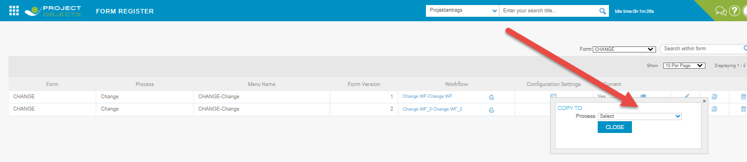

**Version**

Form version is used to make a version for the existing form. DifferFormsForm can be created with the same Form format. The version created does not copy the settings and properties of the existing form, it only copies the Form format and saves it as a version. Form version can be created only after object is created on first version.

1. Click form version icon in form builder.

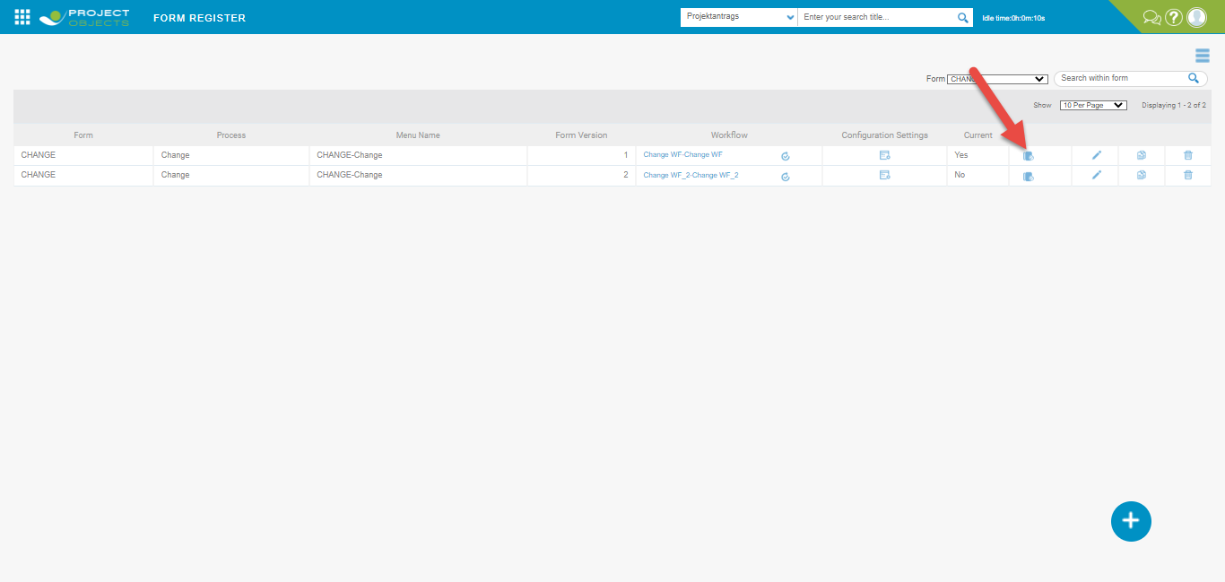

1. We can add the all the controls in the existing form and apply and save.

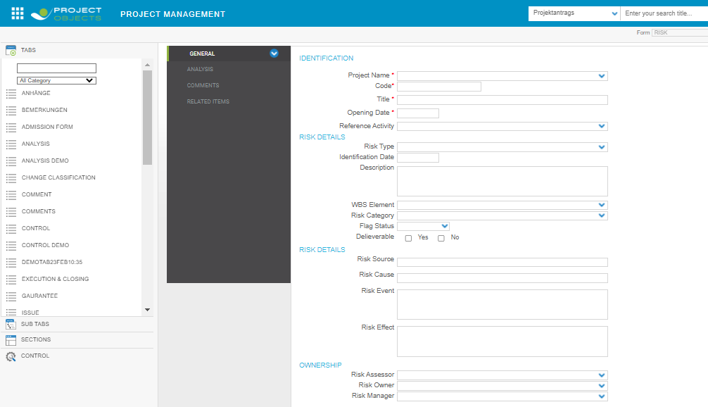

1. Create a workflow for version2 go to workflow designer select workflow type and process. 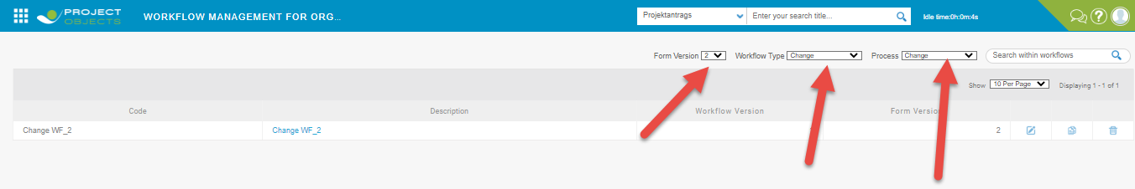
2. Click on create new and fill the required information in 3 tabs.

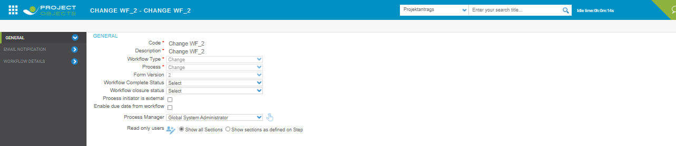

1. After this workflow for form version 2 is created .

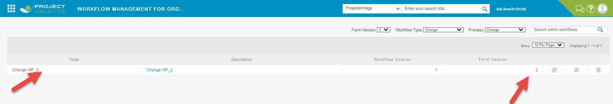

1. In workflow association form version2 are associated like this.

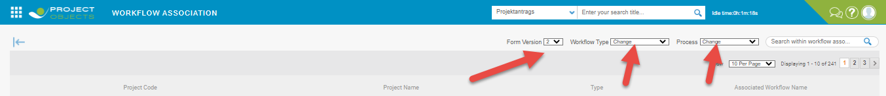

1. After this click on not specified link then associate the workflow to the project and click apply and save.

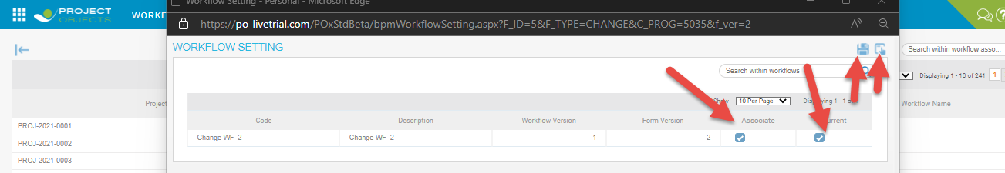

1. After workflow association we go to form builder and select the form.

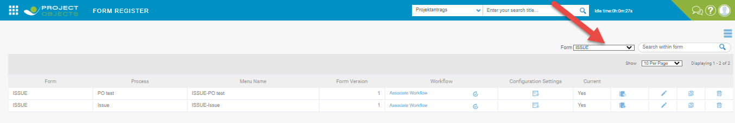

1. select process setting in burger button.

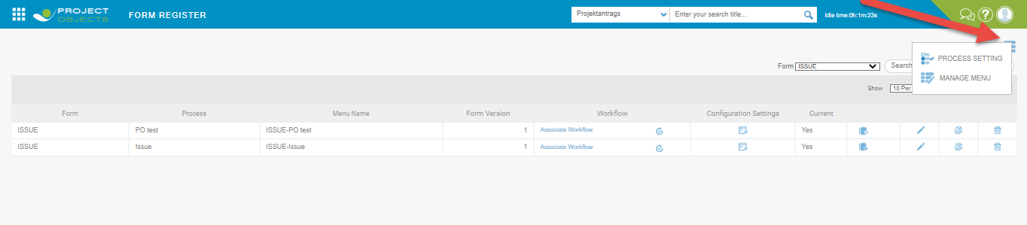

1. After this popup is open select form select form. At this time version 1 is in process.

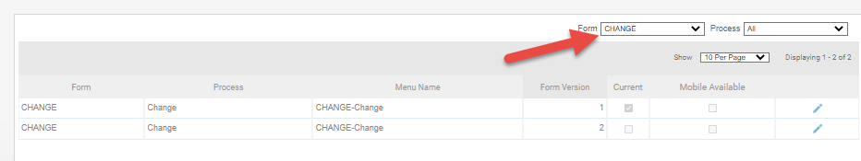

1. Click edit icon clear current checkbox in form version one and apply checkbox in version2 and save.

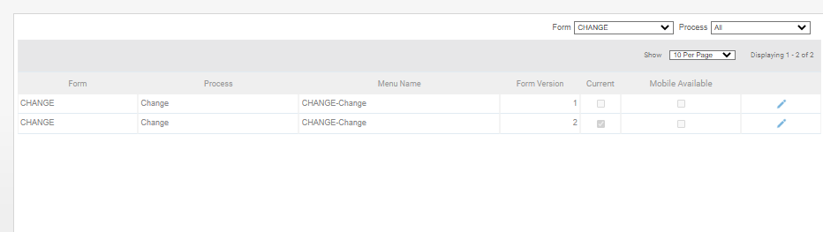

1. After this go to the teamspace for create a object now we create a object form verion2.

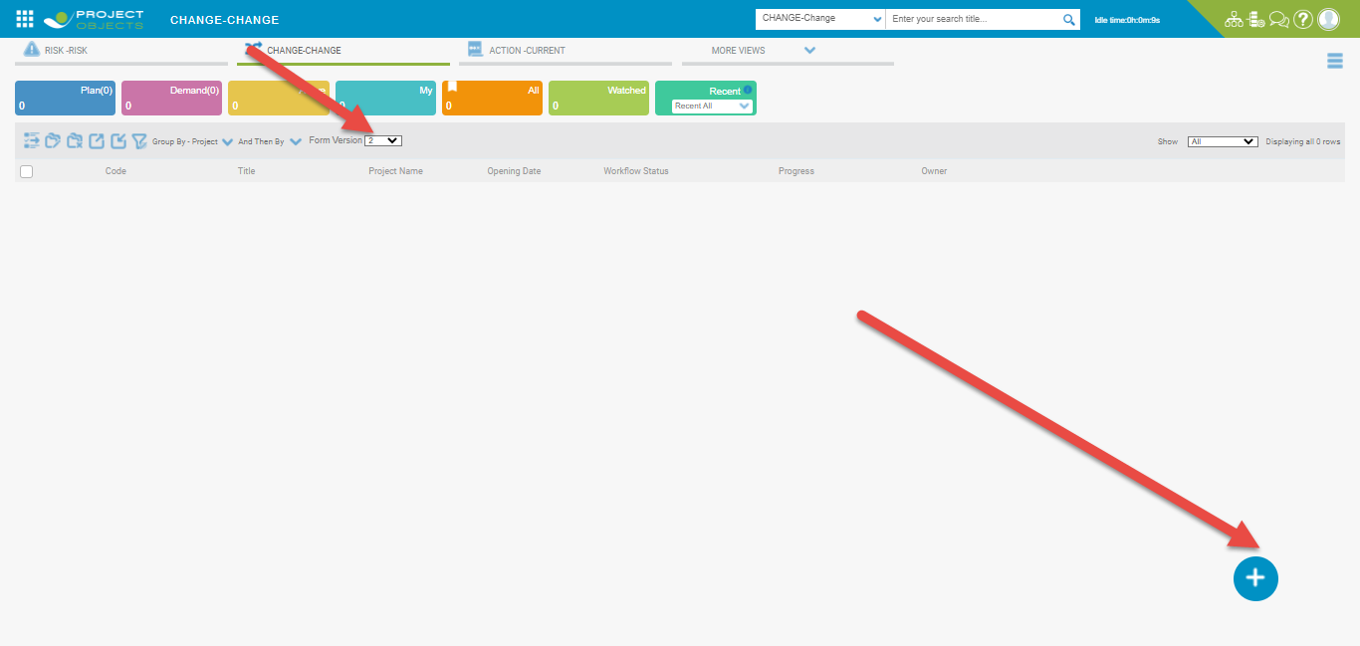

**Configuration Settings**

Field Configuration is used to define the fields available in particular form. We can change the name of field from its standard name with the help of Field Configuration option available here.

1. Click configuration settings in version2

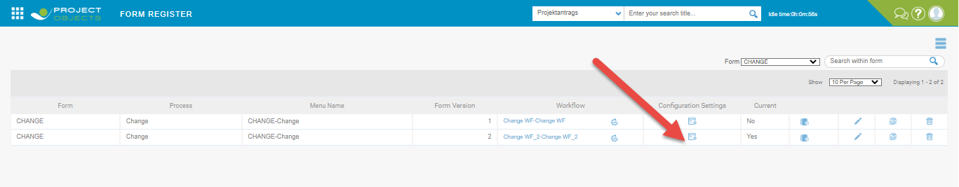

1. We will be go to field configuration widget where we change the name of field which are use in the form.

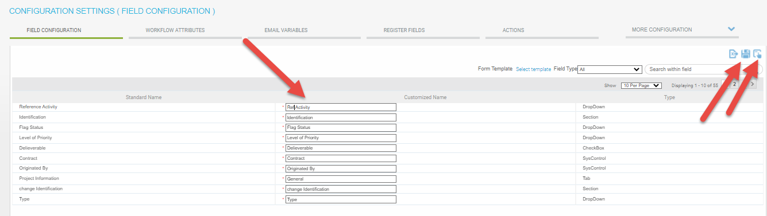

1. Name will be change succesfully.

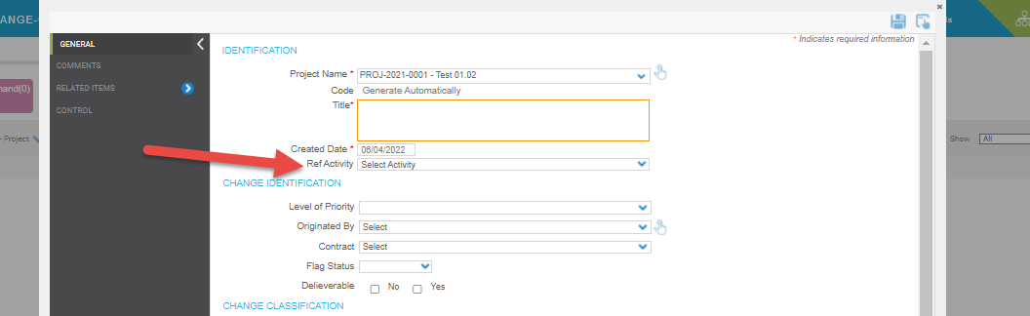

**Email Variables in Field Configuration**

This is used to define the Variables that can be used in Email. These variables will be available while sending mail and can be used in messages for references.

1. Click Email Variables for version 2. Select Type from Available field and move in selected fields using arrow click apply and save.

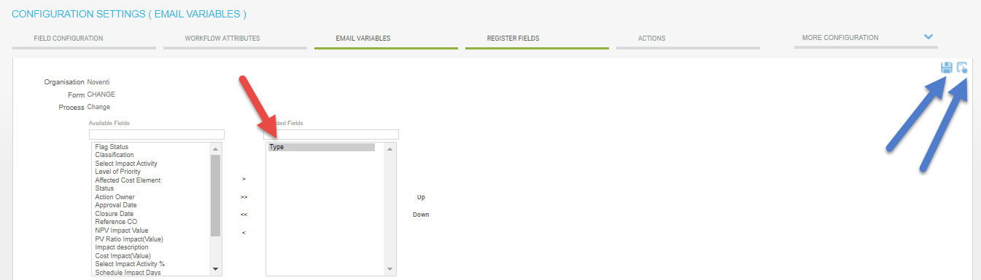

1. Go to the Email setting in message tab Type are added.

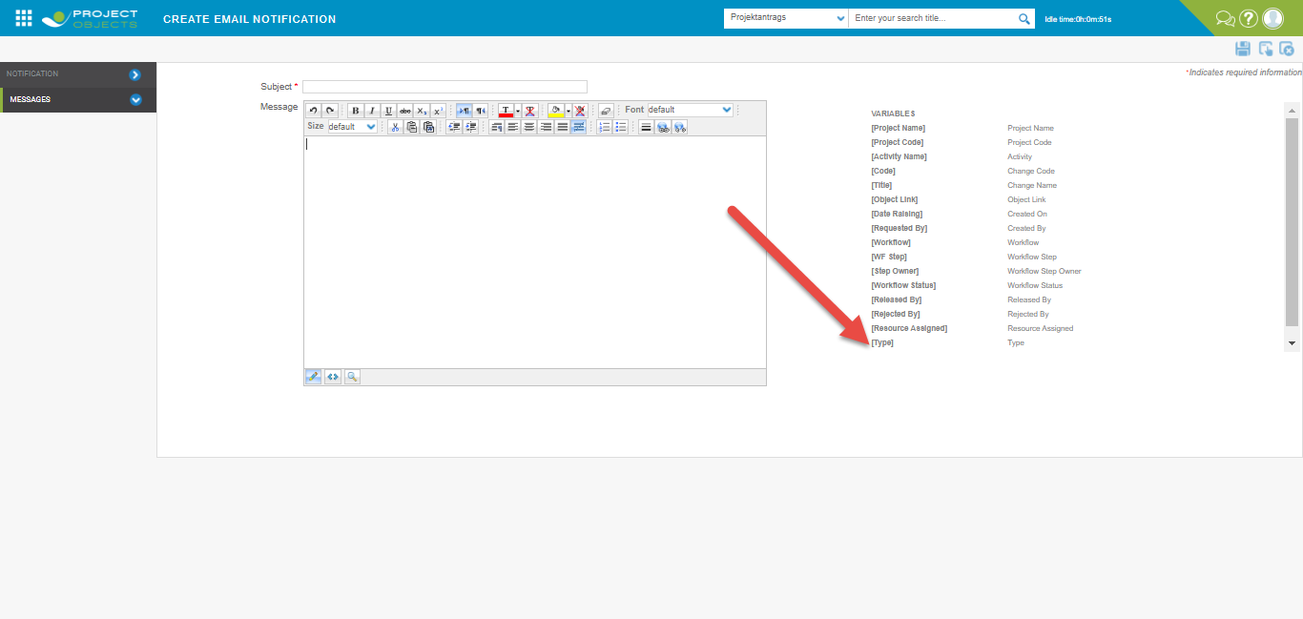

**Register fields in Configuration Settings**

The fields which are avaialble will appear in the form of that particular version

1. Click register field widgets in configuration settings and select flag status from available fields and move to selected fields using arrow icon then click apply and save.

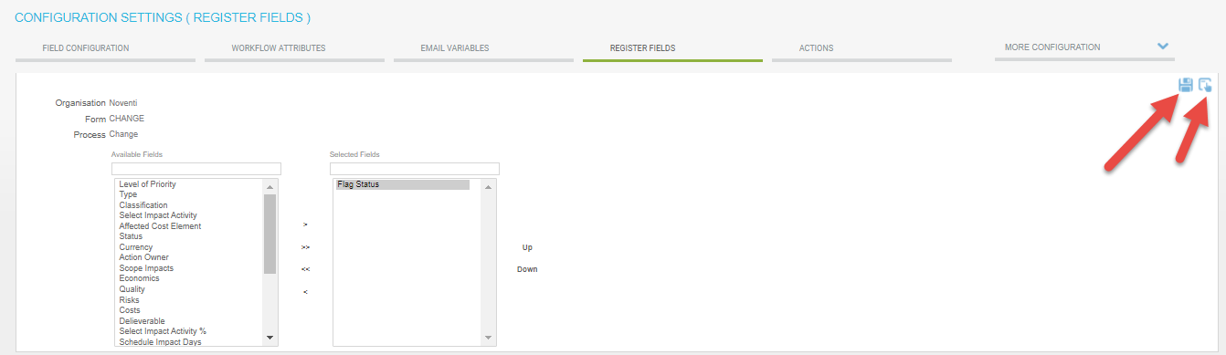

1. Flag status are added on register page.

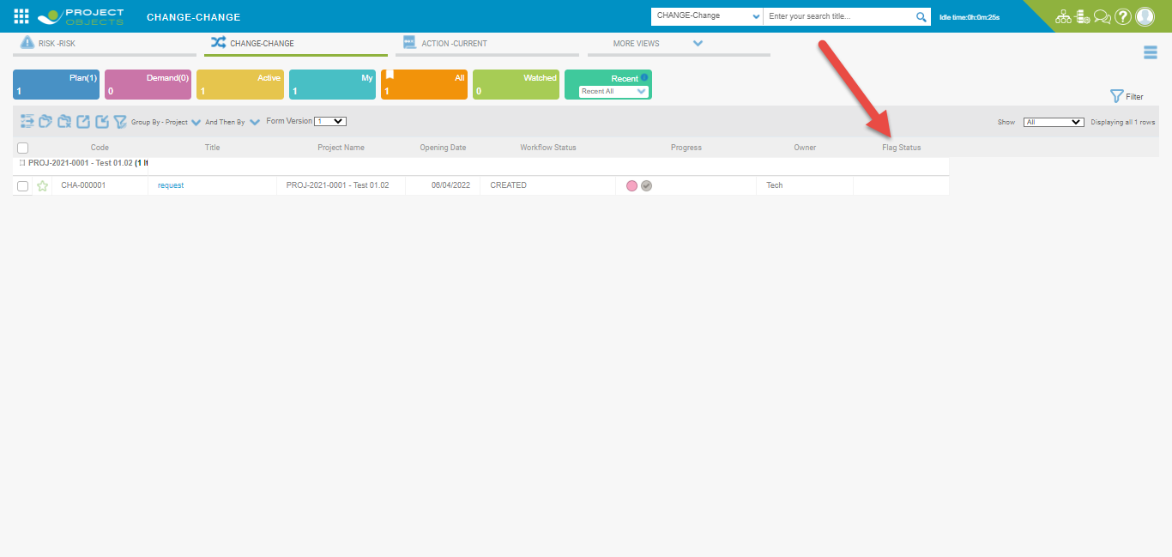

**Action in Field Configuration**

1. Click Actions and click isMandatory field in Approval date and bulk edit in deliverable then apply and save .

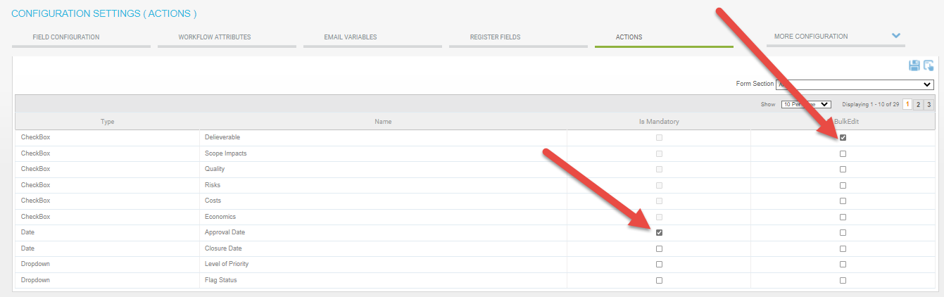

1. After apply we check in the form .

